Dear mom of a baby in Heaven…

An open letter from a fellow mom
By Kristi Bothur
Dear mom of a baby in Heaven
Copyright ©2014 by Kristi Bothur
Cover design by Kristi Bothur
Published by Grace International LLC
Photographs on Cover and page 2, Microsoft Word clipart
All other photographs, Kristi Bothur
Dear mom of a baby in Heaven,
If we were face to face right now, I would say nothing. I would give you a hug and a tissue and then invite you to sit down and tell me about your child. The one who, whether named by you or not, remains nameless in your day to day life. The one you had hopes and dreams for. The one who went ahead of you into glory. The one that almost no one else wants to talk about because they are afraid of reminding you that you would have had a child this age if only things had been different (as if you can forget for even a moment).

If you wanted me to, I would tell you about Naomi, Kyria, Jordan, and Hope, my children in Heaven, and their stories. And then, if you were ready, I would tell you this.
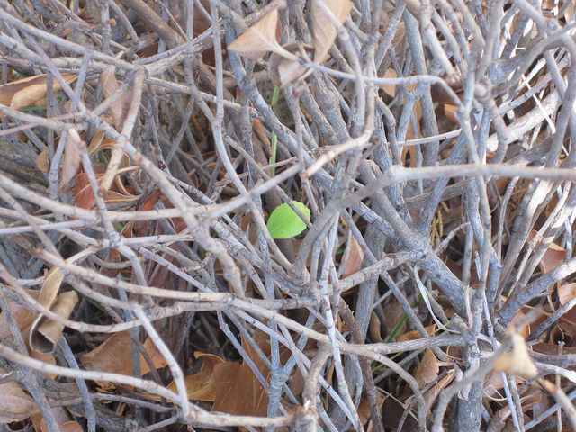
I would tell you that it's not your fault. You didn't cause your baby to die by eating spicy food or carrying a heavy box or by being impatient with your husband or not being a good enough mom to your living children or a good enough daughter or anything else.

Your baby's death was not a punishment for you not being good enough. It’s not something you could have prevented with diet, or exercise, or rest, or by living a perfect life. It is just something horrible that happens in a broken, sin-scarred world. And I am so sorry it happened to you.

I would tell you that you're not going crazy. You probably feel like you are. Maybe you are having flashbacks, or you swear you can feel you baby moving still, or you find yourself checking in the middle of the night to see if your other family members are still breathing. Maybe you can't bear to think of having another baby, or maybe you can't think of anything else.

Whatever you are feeling, I can guarantee that thousands of other bereaved moms have felt the same thing. It's normal. It's not pleasant, but it's normal, especially for those early days of grief. (Please note, however, that this does not mean that every emotion is experienced in a healthy way. If you are contemplating harming yourself or others, or if your emotions are interfering with basic life activities for a longer period of time than expected, please seek help. There is no shame in that.)
I would tell you that you won't always feel this way. Life may seem unbearable right now. Just getting up and facing another day, much less finding joy again, seems impossible. But the intensity and frequency of your feelings will lessen. Time does not heal all by itself, but it does help.

Someday you will wake up and find that it is easier to breathe, to talk, to make plans that don't include your baby. When that happens, you don't have to feel guilty for it. I am not telling you to get over the death of your baby. You won’t, ever. You will never forget. But I want you to have hope that the grief will not always be this heavy and that the future will not look like today.
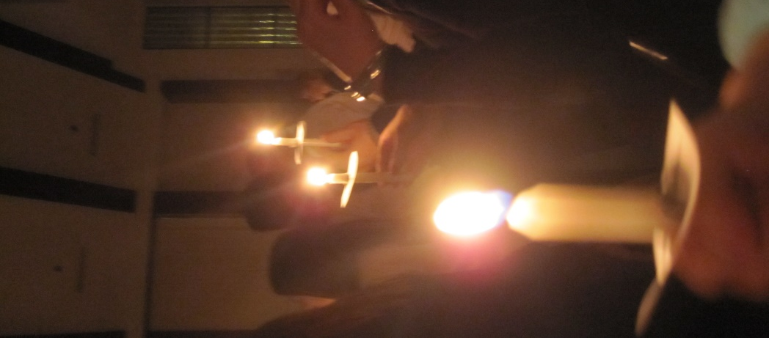
I would tell you that you're not alone. I know you feel alone, but one in four women have experienced the loss of a baby. One in four. There are more bereaved mothers out there than breast cancer patients, and yet it is far more popular to wear pink during the month of October than to talk about our babies in Heaven. The good news is, that silence is being broken more and more these days, and it is easier than ever to find other moms on the same journey from loss to your new normal.

Online, there are thousands of websites, organizations, blogs, Pinterest boards, forums, and Facebook groups where you can find other moms who will understand where you are at and how you feel. But I would encourage you not to stop with online support. Seek out others in your community. Check with hospitals, with your doctor, with churches. Check out organizations like SHARE, October 15th, Griefshare, Mommies with Hope, Sufficient Grace Ministries, and Naomi’s Circle to find other real-life moms in your community who you can join with on this journey.
Finally, I would say that your baby mattered to God – and so do you. You may not be on speaking terms with God right now. You may wonder why God didn't save your baby, or why he even let you get pregnant if he knew it would turn out this way, or if he even noticed the brief existence of a baby who never took a breath, or who lived for such a short time.

But He did.

He noticed. He was there. He is here now. And your baby’s life, however short, had purpose and meaning. As you heal, you will gradually learn what it is. No one can do it for you, but turning to God's Word can help you understand His heart, to draw close to Him, and to trust Him as you rebuild your life.
And then, if we were face to face, I would offer to pray with you, for both of us. For you, as you start this journey. For me, as I still miss my babies, five years later, and still have moments when I wonder what would have been, if only. For both of us, as we help each other on this road called at the same time both Loss and Hope, and as we move forward in faith toward the healing God has for us.
Dear mom of a baby in Heaven, I am so sorry.
It wasn't your fault.
You're not going crazy.
You won't always feel this way.
You're not alone.
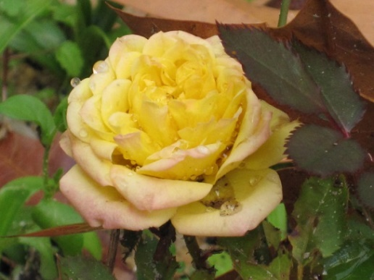
Your baby mattered to God - and so do you.
I promise.
With love,
Kristi
Mother of six, two on Earth and four in Heaven

www.thissideofheaven.weebly.com
www.naomiscircle.org

